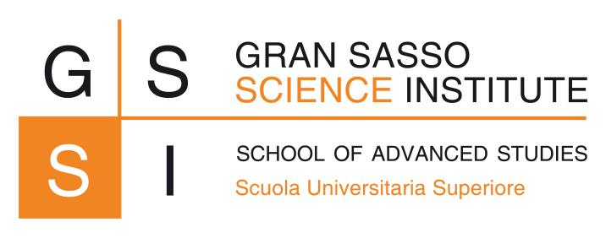

Introduction to Software Engineering

Immigration course

**First Phase Project Report**

PhD Program in Computer Science: XXXVIII cycle

*Authors*: *Supervisors:*

Martina De Sanctis

Oleksandr Skorupskyy Ludovico Iovino

Thomas Boudier Prof. Patrizio Pelliccione

January 8, 2023

# Requirements Specification

# Software Architecture